Bluetooth Car
Abstract:

A remote controlled vehicle is any mobile machine controlled by means that is physically not connected with origin external to the machine. There are many types in it, based on the controls – radio control device, Wi-Fi controlled and even Bluetooth controlled. These devices are always controlled by humans and take no action autonomously. The main target in such vehicles would be to safely reach a designated point, maneuver the area and reach back to the point
of origin.

In this project we make use of the Bluetooth technology to control our machine car. We don’t call this as a robot as this device doesn’t have any sensors. Thereby, sensor less robots are machines. This machine ccan be controlled by any human using his android mobile phone, by downloading an app and connecting it with the Bluetooth module present inside our car.

Materials Used

Arduino Board UNO micro controller
Bluetooth Modules HC-05
Motor Drive Shield AF Motor Driver
DC Gear Motor
12V, 200rpm .

Arduino UNO:

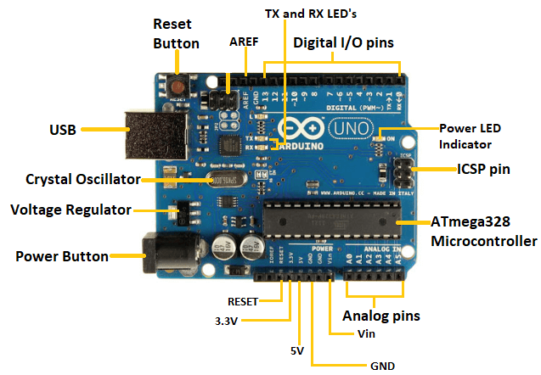

AF Motor Driver

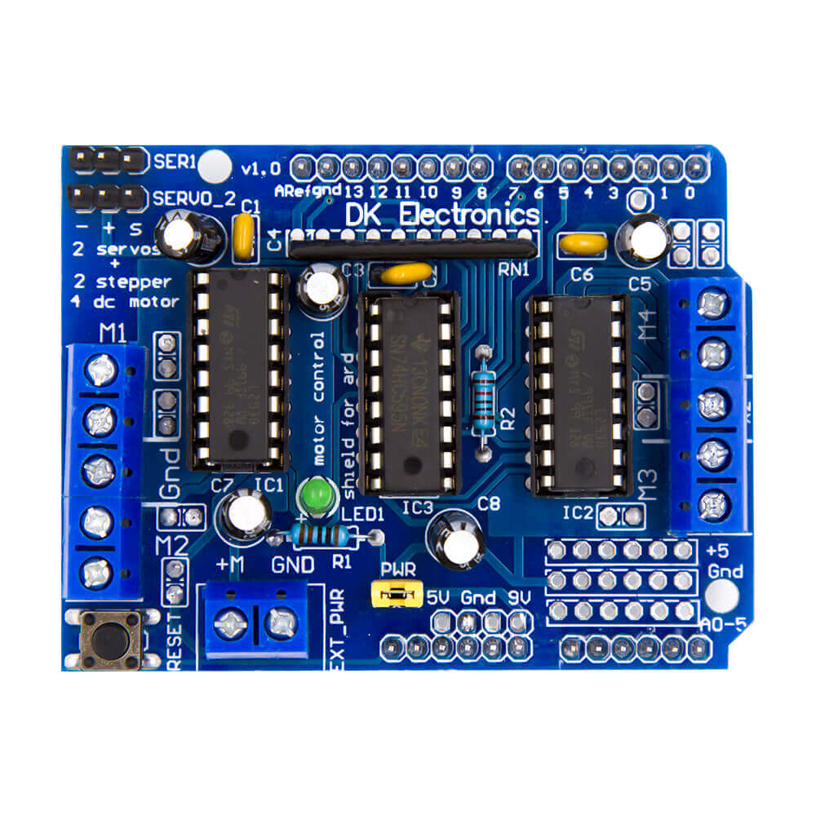

The nature of the way we look at Pins 4 dc motor as can be seen, 2 servo motors and 2 stepper motors can take.That is just not designed to drive DC motors. This aspect is also advantageous. arduino we wear the pins on the Arduino UNO is closed no matter where in addition we need to get out of the arduino has additional pins on the shield. So these pins are used as normal arduino pins. As to be seen in figure analog 0 to 5 and digital 0 to 13 contain additional pins. Furthermore, the supply pins are given a separate output. These models are no pins in addition defined as the change in some shield. In this case, you can get the same output pin to an additional cable while installing the shield i pins. It has a working voltage between 5-12v. Each channel provides 600 mAh flow.

HC05-Bluetooth Module:
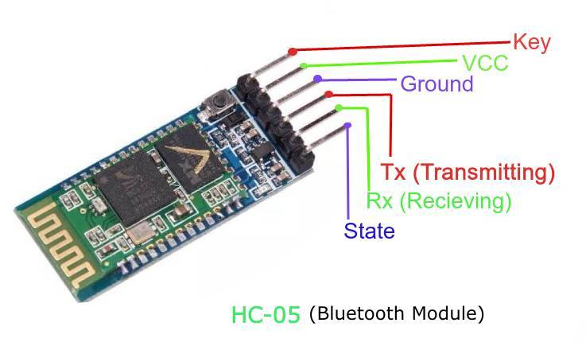

The HC-05 is a class 2 Bluetooth module designed for transparent wireless serial communication. It is pre-configured as a slave Bluetooth device. Once it is paired to a master Bluetooth device such as PC, smart phones and tablet, its operation becomes transparent to the user. All data received through the serial input is immediately transmitted over the air. When the module receives wireless data, it is sent out through the serial interface exactly at it is received.

Circuit Diagram:

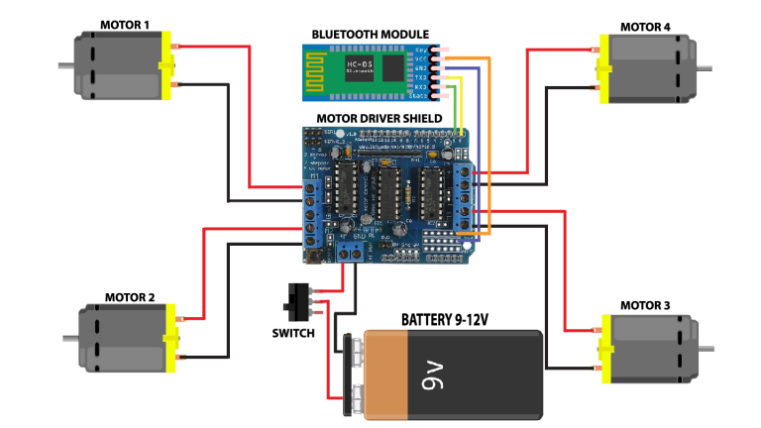
Code:

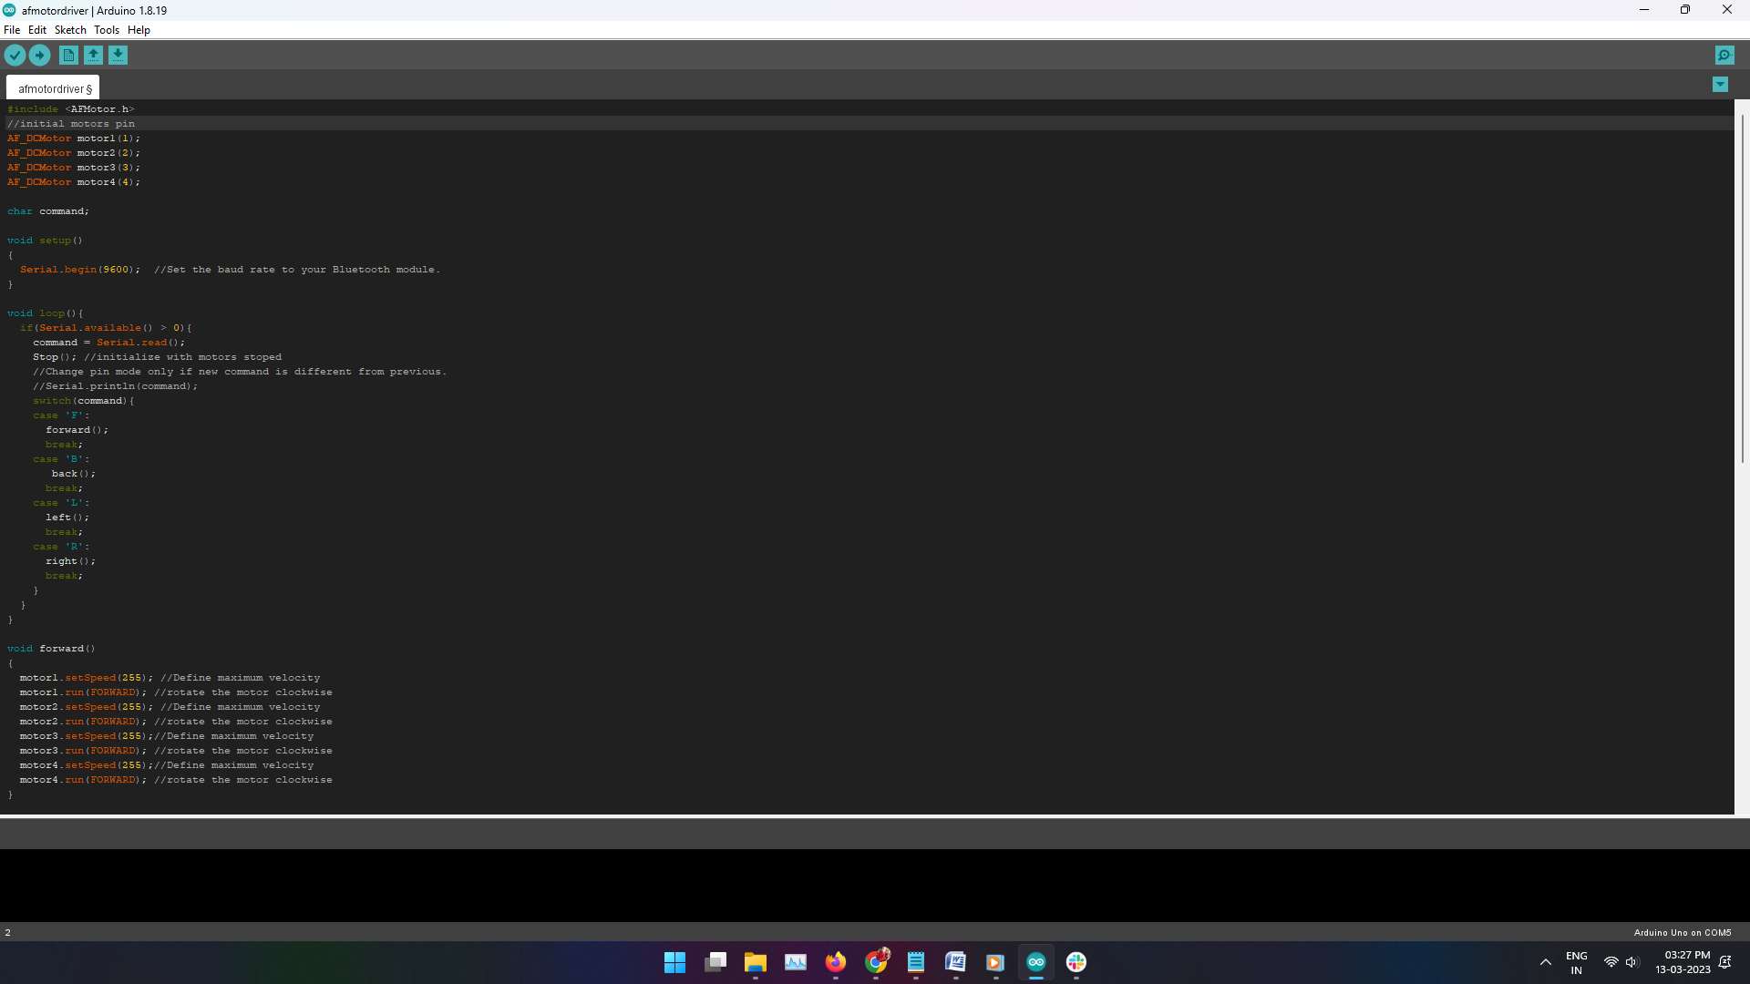


App:

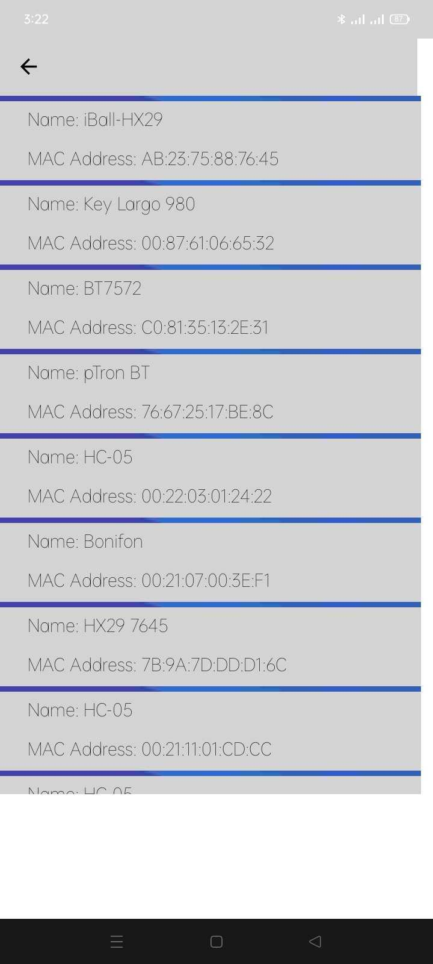

Control GUI:



Conclusion:

The project titled Bluetooth Car using Arduino is an application based on popular open source
technology - Android and Arduino The aim of the project was to create an arduino integrated car
that has to be controlled through an application that runs on the android operating system. The
project has been completed with success with the utmost satisfaction. The constraints square
measure met and overcome with success. The system styled /is meant/ is intended as find it
irresistible was set within the design section.

